Solution Delivery Queue: How It Works
Oct 27, 2026 · @Chioma

What the portal is for
The Solution Delivery Queue is one shared page where anyone can see where every IT solution request stands, from the first prototype to after go-live.
It answers three questions at a glance:
- Where is my request? Every request shows its current step and how long it has been there.
- Who are we waiting on? Each request says whether IT or the process owner needs to act next.
- When will it be done? Once a plan is agreed, the portal shows the planned go-live date and flags any phase that runs late.
Requests are built first come, first served. A request gets its place in the queue on the day IT accepts it, not the day it is submitted.

Who does what
There are three roles. The badge at the top right of the portal tells you which one you have ("You: IT admin", "You: Process owner" or "You: Viewer").
Role | Who holds it | What they do in the portal | Access to give
IT admin | IT | Reviews scope, accepts or declines requests, owns the queue, agrees timelines with the process owner, assigns IT resources, moves work through design, development, QA and deployment, decides who caused a rejection, applies the 5-day UAT rule, closes out solutions | Editor
Process owner | A department-approved person in the business | Submits the prototype, verifies the UI/UX design, confirms the UAT session within 5 working days, accepts or rejects UAT, resubmits when a request is sent back, logs bugs after go-live | Contributor
Viewer | Anyone who wants to follow what IT is working on | Sees the queue, every request's progress, plans, history and the bug queue. Cannot submit, upload, edit or log anything. | Viewer
Only IT admins can set queue positions, timelines and resource assignments; the portal refuses these changes from anyone else. Access is given by the page owner from the portal's Share menu.

The journey of a request
Every request moves through the same steps. Open any request in the portal to see a progress bar across the top and a Next step box that says who acts and which button to press.
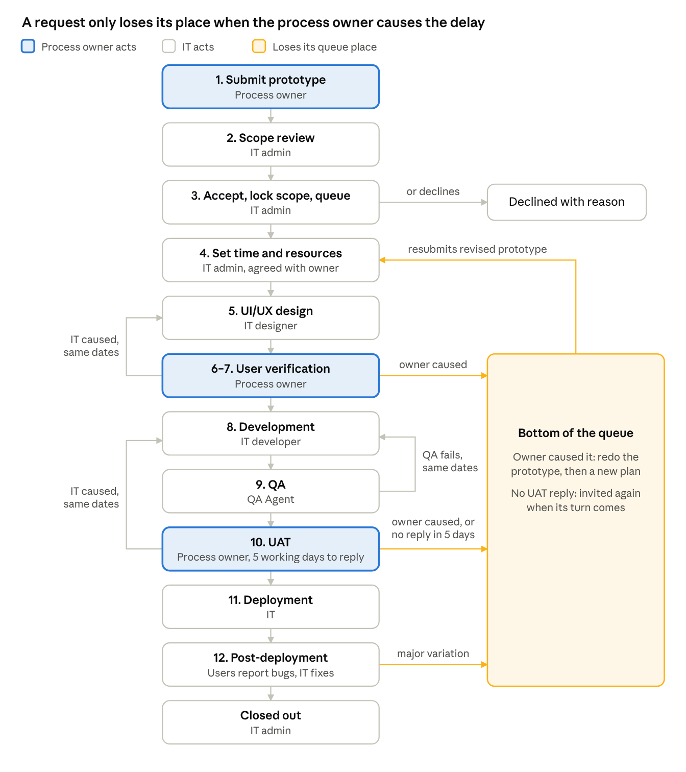
request flow · 12 steps, with rework loops
When IT caused a problem, the request loops back with the same dates. When the process owner caused it, the request drops to the bottom of the queue.
Step | Who acts | What happens | What to press in the portal
1. Submit | Process owner | Submits the prototype, with the name of the department head who approved them | + Submit a prototype (top right)
2. Scope review | IT admin | Reviews the scope with the process owner | Start scope review
3. Accept and queue | IT admin | Records where the BRD and prototype are kept and locks the scope. The request takes the next place in the queue. Or declines it with a reason. | Accept & lock scope or Decline
4. Time and resources | IT admin, agreed with the process owner | Sets the start date, working days per phase and the person or team for each phase | Set time & resources
5. UI/UX design | IT (designer) | Designs within the agreed window | Design complete → send for verification
6–7. User verification | Process owner | Checks the design. If it is wrong, writes what is different; the IT admin then decides the cause (see Queue rules). | Accept design or Reject design
8. Development | IT (developer) | Builds within the allocated time | Development complete → QA
9. QA | QA Agent | Tests the build. A failure goes back to development with no extra time. | QA passed → invite to UAT or QA failed
10. UAT | Process owner | Has 5 working days to confirm a test session, then tests. If it is wrong, writes where; the IT admin decides the cause. | Confirm UAT session, then Accept → deploy or Not accepted
11. Deployment | IT | Deploys and tells users to begin testing | Deployed & users notified
12. Post-deployment | Users, process owner, IT | Users test and report bugs; IT fixes them in order. IT closes the request when the review is done. | Log a bug, Mark fixed, Close out

Queue rules
A request keeps its place in the queue unless the process owner causes a delay or a change; then it drops to the bottom.
Situation | What the portal does | Effect on timeline | Effect on queue
Request submitted | Shows it under Intake | None yet | No position until IT accepts it
IT accepts the request | Locks the scope | Plan is set at step 4 | Takes the next position
Design or UAT rejected: IT did not build what was presented | IT redoes the work; counted as IT rework | Not extended. IT bears the cost. | Keeps its position
Design or UAT rejected: process owner did not capture the requirement | Sent back to the process owner to redo the prototype; counted as Owner rework | Plan cancelled; a new one is agreed after resubmission | Moves to the bottom
QA fails | Back to development | Not extended | Keeps its position
No reply to the UAT invitation within 5 working days | IT admin applies the 5-day rule | Not extended | Moves to the bottom
Major variation from the process owner after go-live | Treated as new scope and sent back | Plan cancelled | Moves to the end
Bugs after go-live | Added to the Bug queue | None | Fixed in the order reported, across all solutions
When a design or UAT is rejected, the process owner only records what is wrong. The IT admin then agrees with the process owner where the discrepancy came from and records it under Determine cause. Every decision is kept in the request's history with who made it and when.

Finding your way around
The portal has four tabs. Click any request in any list to open its detail panel.
Tab | Who uses it | What you see
Pipeline | Everyone | Summary counts, The queue in order with position numbers, Intake (waiting for review) and Closed requests. Filter by department at the top of the queue.
IT admin | IT admins only | Work needing IT action, grouped: Determine the cause, UAT 5-day rule, Scope review, Set time and resources, In build, Waiting on process owners. Also Resource load (who is busy or available) and the IT resources list.
Bug queue | Everyone | Open bugs in the order they were reported, and recently fixed ones
Process rules | Everyone | The steps, roles and rules in short form
The detail panel of a request shows, from top to bottom: its queue position and who it is waiting on, a progress bar, the Next step box, the time and resources plan (with a red line for today), the request and scope details, any bugs, and the full history.
Status labels use colour so you can scan quickly:
- Blue: IT is working on it (design, development, QA, deployment, awaiting allocation)
- Amber: waiting on the process owner (verification, UAT, sent back)
- Red: disputed, needs the IT admin to determine the cause
- Green: live or completed
- Grey: submitted or in scope review
- A red late tag means a phase has passed its planned end date.

Common tasks
Submit a new request (process owner)
- Click + Submit a prototype at the top right.
- Fill in the solution name, department, your name, the department head who approved you, what the solution should do, and where the prototype is kept.
- Click Submit prototype. The request appears under Intake on the Pipeline tab.
Check where your request is (anyone)
- On the Pipeline tab, find your request in The queue or Intake. Use the department filter if the list is long.
- Read the Stage and Waiting on columns. Click the row for the full detail and history.
Set time and resources (IT admin)
- Agree the timeline with the process owner first.
- On the IT admin tab, check Resource load to see who is available.
- Open the request under Set time and resources and click Set time & resources.
- Enter the start date, working days per phase and the person or team for each phase, then click Save plan and start UI/UX.
Report a bug after go-live (process owners and IT)
- Open the live solution from the Pipeline tab.
- Click Log a bug, describe it and click Log bug. It joins the Bug queue in the order reported.

Frequently asked questions
I submitted my request. Why does it have no queue number? A request is only queued when IT accepts it after scope review. Until then it sits under Intake.
Why did my request drop to the bottom of the queue? One of three things happened: the IT admin found that a rejected design or UAT came from requirements you had not captured, you did not reply to the UAT invitation within 5 working days, or you asked for a major change after go-live. The history on the request says which, with the date and a note.
IT got it wrong. Will my go-live date move? No. When the cause is IT's, IT fixes it within the agreed dates.
Are the durations in calendar days? Phase durations are working days, Monday to Friday. The 5-day UAT reply window also counts working days.
I can see the IT admin tab but it says "For IT admins". You have process owner access. Ask the portal owner if you need IT admin access.
I only want to follow what IT is doing. What access do I need? Viewer access. You can see the queue, each request's progress and the bug queue, but you cannot submit or change anything. Ask the portal owner for it.

